**Aim:** Installation and Setting of LAMP/WAMP/XAMPP

**Theory:-**

**Setting up the environment(LAMP/XAMP/WAMP server)**

* WAMP, LAMP and XAMPP acts as local servers which are used to develop PHP website on localhost.
* The primary difference between WAMP, LAMP, and  XAMPP is of the operating system. WAMP is used for Windows, LAMP for Linux, and XAMPP can be used for any operating system.

**WAMP**

* WAMP is used for Windows operating system only.
* Its full form is Windows, **A**pache, **M**ySQL and **P**HP
* It is an open source platform.
* It uses the Apache web server.
* Relational database management system for WAMP is MySQL.
* PHP (Hypertext Preprocessor) is the object-oriented scripting language.
* WAMP is very easy to setup and configure.

**LAMP**

* LAMP is used for Linux operating system only.
* Its full form is Linux, **A**pache, **M**ySQL and **P**HP
* It is also an open source platform.
* It uses the Apache web server.
* Relational database management system for LAMP is MySQL.
* PHP (Hypertext Preprocessor) is the object-oriented scripting language.

**XAMPP**

* XAMPP can be used for any operating system.
* Its full form is x-os, **A**pache, **M**Y-SQL,**P**HP, and **P**erl.
* X-os implies that it is cross platform application and can be used for any operating system.
* It is free, open source, cross-platform web server solution pack
* XAMPP comes with extra features like supporting of perl, filezilla, mercury mail and some other scripts.
* It is simple, lightweight and easy to use for developers in creating local web server

**Steps for installing XAMPP on Windows 10**

1. Download XAMPP from Apache Friends.
2. Double-click the file to run the installer.
3. Click the OK button on the warning to continue.

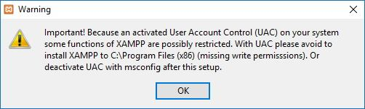

1. **Click the Next button.**

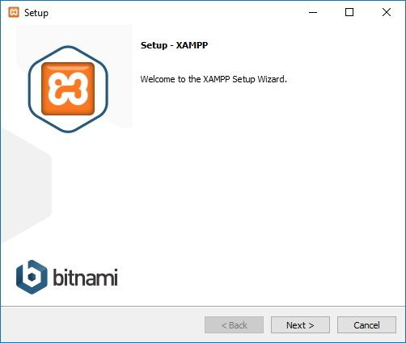

**5.XAMPP offers a variety of components that you can install, such as MySQL, phpMyAdmin, PHP, Apache, and more. For the most part, you will be using most of these components, as such it’s recommended to leave the default options and click the Next button.**

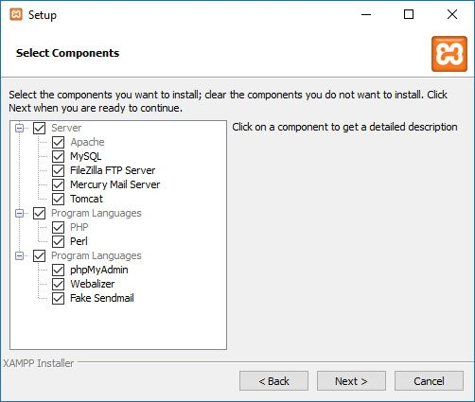

**6. Use the default install location settings, or choose another folder to install the software, and click the Next button.**

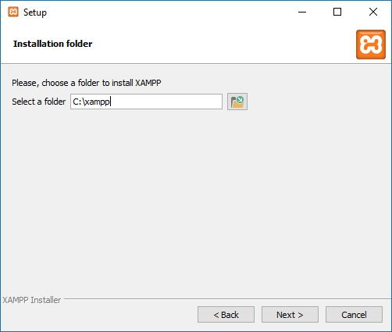

**7. Clear the Learn more about Bitnami for XAMPP option.**

**8. Click the Next button.**

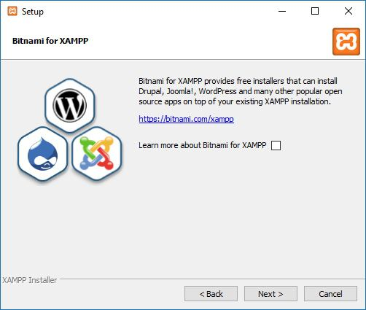

**9. Click the Allow access button to allow the app through the firewall (if applicable).**

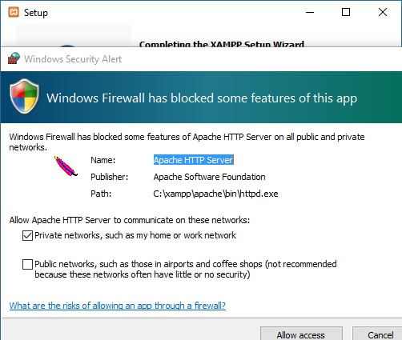

**10. Click the Finish button.**

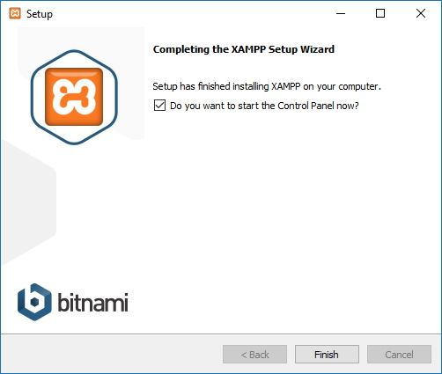

**11. Choose your language (English or German).**

**12. Click the Save button.**

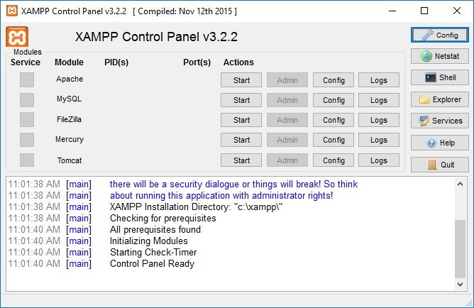

* **Once you’ve completed the steps, the XAMPP Control Panel will launch, and you can begin the web server environment configuration.**